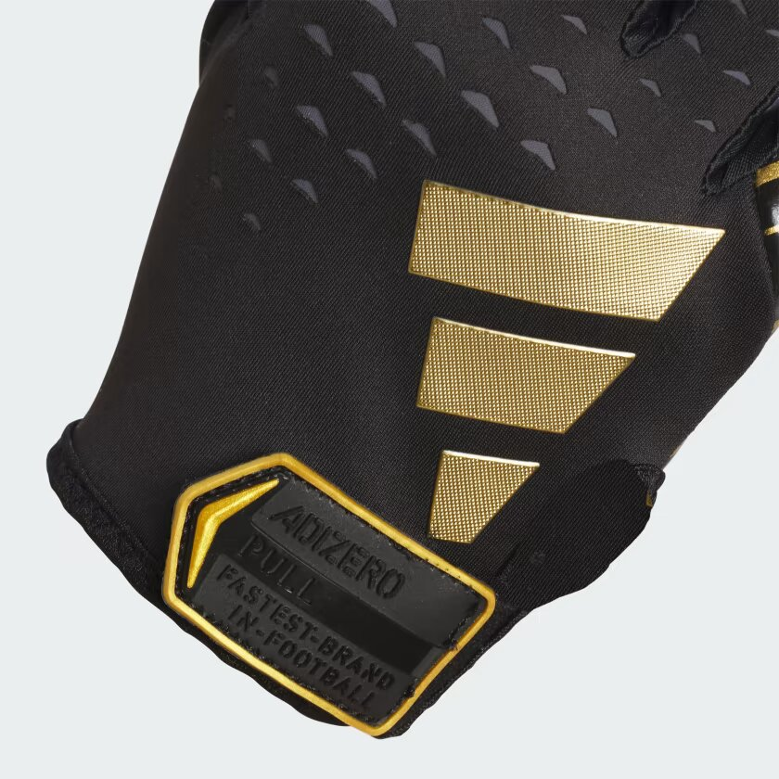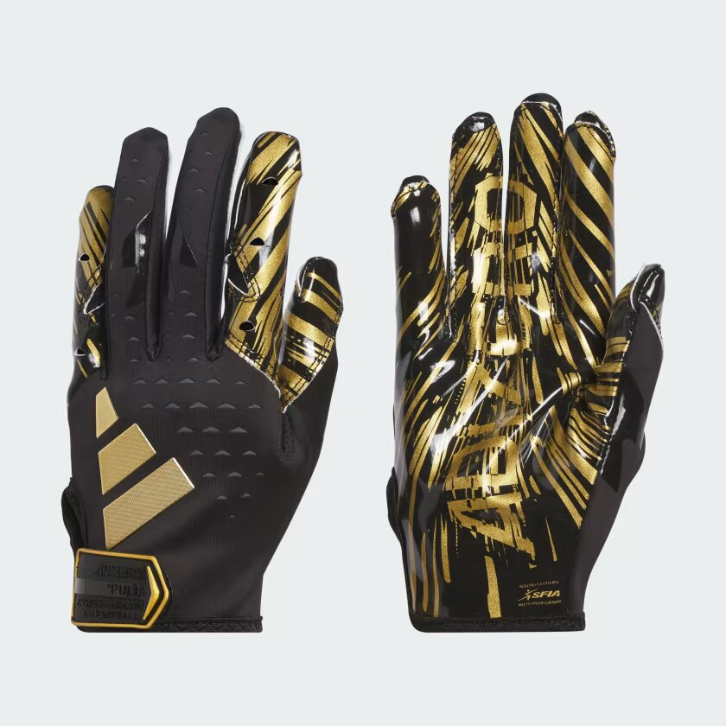

ADIDAS ADIZERO 13 GLOVES

Always be ready to play with the Adizero 13 Receiver’s Glove from adidas! Designed to provide exceptional comfort and grip to keep up with intense gameplay. Featuring box fingertip construction to deliver a superior fit for your fingertips, without any pinching or tightness. It includes a custom molded tab with no-snag hook and loop closure to make sure it is always secure. Airprene breathable band for increased movement and to reduce heat buildup. Enhance your game with Adizero 13 Football Gloves for receivers! Football receiver gloves that are carefully made with ergonomically designed support zones on fingers to allow for maximum flexibility and fit, assuring the highest level of performance available.

**DETAILS:**

* Imported
* Product color: Black G
* Product code: IR3810